Hello Team Raposa Family,
We are very excited to partner with the East Hanover Child Care Center to provide our Little Tigers Taekwondo Program. There is nothing more satisfying to a martial arts Master than to introduce new students to the arts. Our name is Team Raposa, we keep the word Team in the name to remember that in the martial arts, we support each other and grow together.
Our specialty is Taekwondo, which was first introduced to the Olympics in 1988. Taekwondo is a competitive college sport with major Universities such as NYU, Columbia, Cornell and Princeton all having Taekwondo Teams. By training with us, you will have the opportunity to continue training at any of the many Universities currently offering Taekwondo programs. As a young athlete, you too will have the opportunity to compete, as long as you train hard and dedicate yourself. Team Raposa has consistently developed many successful youth athletes of many ages in the USA Taekwondo competition circuit.
The increased discipline and focus will help improve our student’s academics. Remember, school always comes first! Through regular Taekwondo training, you will develop a calm, disciplined and goal oriented mind. We are here for you and always available to talk.
Classes will be: Thursdays 10:00am
Session 1: $15 per class for 9 classes - $135 for Session 1
East Hanover Childcare Center
We are looking forward to starting in this journey of growth and development together. See you in class!

P.S. my son is also a member of EHCCC, but he’s a little too young for Taekwondo 😊

Master Vinny Raposa,
Team Raposa Taekwondo
460 Ridgedale Ave, East Hanover, NJ 07936
www.teamraposa.com
862-305-0369

Last Name ________________________ First Name (parent)_____________________________________

Student Name __________________________________________________________________________

Student Date of Birth _____________________________________________________________________

Phone #__________________________ Alternative Phone #_____________________________________

E-mail address: __________________________________________________________________________

Mailing address: _________________________________________________________________________

Facebook Name: ______________________________ Facebook Handle _@_________________________

Instagram Handle: _@_________________________

The student is aware in making this agreement to participate in training in the Team Raposa, LLC and Cultural Integration and Arts Association program that certain elements of this training are physically demanding and potentially dangerous, and with this knowledge agrees to indemnify and hold harmless from all losses caused by accident or injury the Instructor, his assistants, or any third parties who may be students of the same class or who are students with the Instructor, in the event that the student or that said third party is injured in any way during the proper performance and execution of techniques or instruction provided in this training.
This release shall also include any landlord or leaseholder of any training facility in which training is conducted. I also agree that the terms hereof shall serve as a release and assumption of risk for my heirs, executors and administrators, and for all members of my family, including any minors.
The student attests that he/she is in good physical condition and has no known or suspected medical conditions that would preclude vigorous physical activity.
It is further agreed that the student’s name, photograph or other representation for the purposes of promotion or publicity for this Taekwondo program or the instructor/school may be used.
As part of the consideration for participation, the student acknowledges and assumes all these risks and wishes to enroll in this course of instruction.

Print Name:
*Signature: Date:
*Parent or legal guardian must sign all persons under 18 years of age.

Order Form
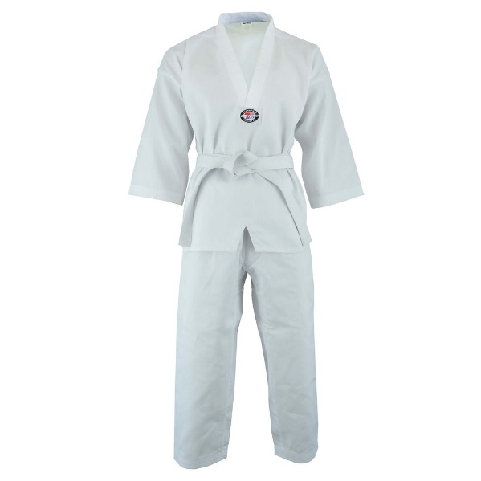

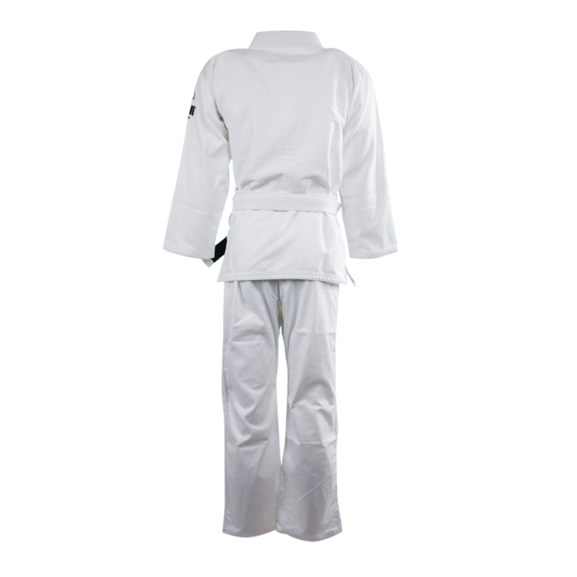

$39.99
Uniform
$19.99
Shirt

-----------------------------------------------------------------------------
Last Name ________________________ First Name (parent)_____________________________________

Student Name __________________________________________________________________________

Shirt Size ______ Credit/Debit Card _______ Cash ________ Check ________

Print Name:
*Signature: Date:
Credit Card Number ______________________ Exp. Date _________ 3-digit Code __________________
Cardholder Name ______________________ Cardholder Address ________________________________

